Independent Sewerage Adoption Panel
Water UK
36 Broadway
London
SW1H 0BH
3rd February 2023
F.A.O. Michael Deakin
Ofwat
Centre City Tower
7 Hill Street
Birmingham
B5 4UA
By email only to Michael.Deakin@ofwat.gov.uk and codeforadoption@ofwat.gov.uk

Dear Michael
Independent Sewerage Adoption Panel (‘the Panel’)
Change Proposal by Vistry: Change position of reducing slab over cover slab
I write further to the above and to the Change Proposal (‘the Proposal’) submitted to the Panel by Vistry East Midlands Division (‘Vistry’) and published on the Panel’s website on 5th September 2022.
The Panel has now considered the Proposal and I have set out below the details of the Proposal, the Panel’s process for consideration of it, and finally the Panel’s recommendation to Ofwat on the proposal.
I enclose a copy of the Proposal with this letter as an appendix and for ease of reference.
The Proposal
In the Change Proposal form submitted to the Panel, Vistry stated that:
The reducing slab is shown central and square to the cover slab, it should be eccentric as per the sketch detail below. The image on the left is wrong and how it is shown on the detail. The image on the right is how it should look.

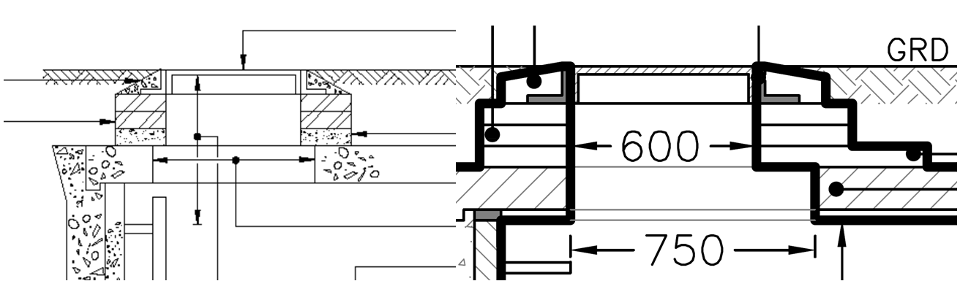
Vistry proposed that changes would be required to the following diagrams in the Code documentation to alter the position of the slab:
Figures B4, B5, B6, B7, B8
The Panel’s consideration of the Proposal and consultation
The Panel considered the Proposal at meetings on 6th September 2022 and 19th December 2022.

In considering the Proposal, the Panel has:
- discussed the Proposal at two meetings
- sought feedback from members’ companies
- consulted with its Technical Sub-Group
- consulted with water companies via Water UK’s Standards Board
- consulted with the Water Research Council (‘WRc’) and asked them to review the diagram

The minutes of the Panel’s meetings when the Proposal was discussed are also enclosed as appendices. The comments received from companies in response to the Panel’s consultation is also enclosed.

The Panel’s recommendation to Ofwat

In accordance with its Terms of Reference, the Panel has assessed the Change Proposal in terms of:
(a) the need for the change, for example, is it a service improvement or is it needed to address a particular issue;
(b) consistency with the principles and objectives of the Code, and any relevant statutory or regulatory requirements; and
(c) the impact of the change (be it positive and/or negative) on Customers and on Sewerage Companies.

In reaching its decision on the Proposal, the Panel has taken into account the following issues:

- The proposal appears to have conflated diagrams for manholes with ladders with those with step rungs. In particular, the response from the WUK Standards Board clarified this point:
  - Step rungs nominally project 125mm from the face of the manhole chamber but ladders nominally project 200mm. To accommodate these different offset distances the corbel slab is placed in different positions. It would be flush with the edge as drawn by your correspondent if there are step rungs in the chamber but it would be offset by 75mm as shown in the Sewerage Sector Guidance in the case of a ladder.
- Accordingly, the Panel was not satisfied that the figures in the DCG should be amended as proposed, as this would create errors depending on the type of manhole being used.
- The change proposal did highlight the potential for confusion in the DCG as currently drafted and the issue around the different types of manholes could be clarified. Accordingly, the Panel decided to ask WRc to review the diagram and make suggestions to clarify this.

Therefore the Panel concluded that, although it was not persuaded to recommend the specific changes to Figures B4-8 set out in the Proposal (for the reasons given above), the Code could be improved to clarify the diagrams on the basis of the issues raised by Vistry in the change proposal. The Panel asked WRc to review this and suggest any improvements that could be made to provide greater clarity.

The Panel therefore recommends that the following changes are made to the DCG:

- Insert the following wording at the end of paragraph B5.2.28:

“The stand-off distance from the wall of the manhole to the rungs of a ladder is typically greater than the stand-off for double step rungs. To align the opening correctly using standard components, a cover slab with a larger opening should be used together a corbel slab to avoid the ladder obstructing the clear opening.”

- Amend the note on the corbel slab in figures B4 to B8 to read:

“Corbel slab to E.30.2 aligned so that the ladder does not reduce the clear opening of the cover (see B5.2.28)”

As the change is for clarification rather than a substantive change, the Panel is mindful that making frequent small changes to the Code documentation could cause confusion. Therefore, the Panel recommends that the change itself should take effect from 1st April 2024. This is in line with the commencement of water undertakers’ new charging year and allows time for undertakers to make any changes to their own documentation required by the change.

This decision reflects the consensus of all members of the Panel following consideration of the Proposal at the meeting on 19th December 2022. This recommendation was made on the basis that it clarifies the Code documentation and supports consistency across the Code documentation. The Panel was satisfied that the change proposed enables the DCG to better meet the principles of the Code.

I confirm that a copy of this letter has been sent to Vistry and has also been published on the Panel’s website.
If you require any further information or if the Panel can assist any further regarding the Proposal, please let me know.
Yours sincerely,
Victor Olowe
Chair
Independent Sewerage Adoption Panel

