Sewerage Adoption Panel – change proposal from Vistry

Consultation responses

- United Utilities (via Technical Sub-Group)

United Utilities standard detail which we use for S185 works/UU works, are below and align with the detail provided by Vistry. We would have no issue with the change in DCG detail.
We would however suggest, that if the cover slab was 600 x600 to match the cover and frame, it would make the overhang/eccentric positioning issue irrelevant.

Step rung access

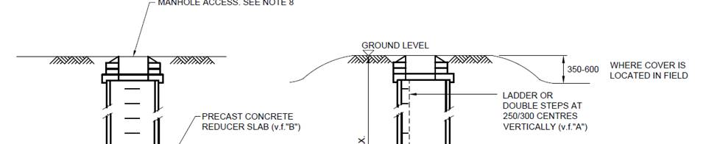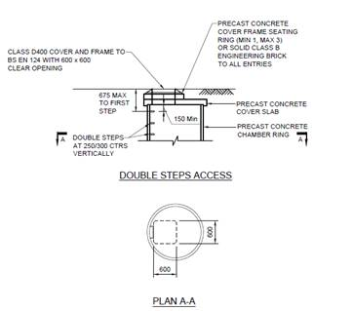

Ladder Access
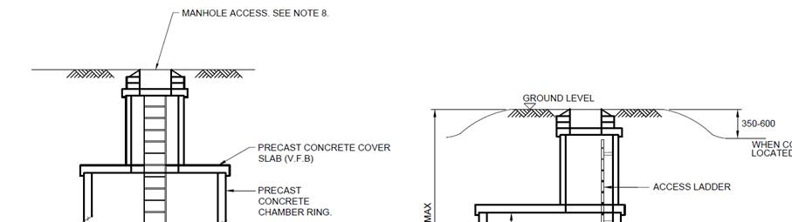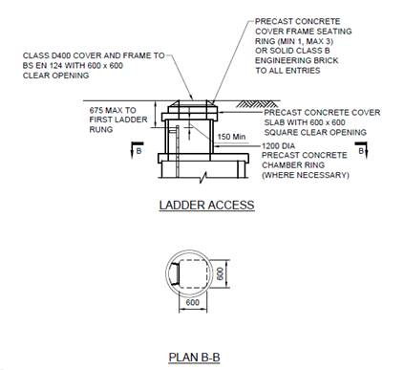

- Don Ridgers (via WUK Standards Committee)

Your correspondent is confused between the situations where there is a ladder and the situations where there are step rungs.

Step rungs nominally project 125mm from the face of the manhole chamber but ladders nominally project 200mm. To accommodate these different offset distances the corbel slab is placed in different positions. It would be flush with the edge as drawn by your correspondent if there are step rungs in the chamber but it would be offset by 75mm as shown in the Sewerage Sector Guidance in the case of a ladder.

The situation is explained clearly in BS5911-3:2022 Fig 1.
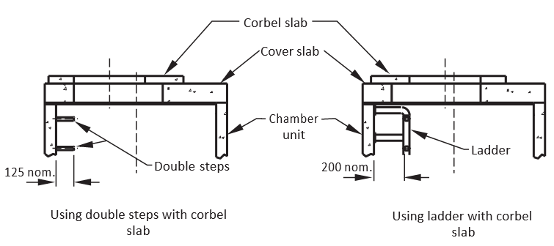

Regards

Don

Don Ridgers Ltd

