Independent Sewerage Adoption Panel
Water UK
36 Broadway
London
SW1H 0BH
5th January 2022
F.A.O. Michael Deakin
Ofwat
Centre City Tower
7 Hill Street
Birmingham
B5 4UA
By email only to Michael.Deakin@ofwat.gov.uk

Dear Michael
Independent Sewerage Adoption Panel (‘the Panel’)
Change proposal by ADS Pipes: Add new sub-clauses into DCG for Plastic Corrugated Wall Arch Structures for below ground stormwater attenuation and storage applications
I write further to the above and to the Change Proposal (‘the Proposal’) submitted to the Panel by ADS Pipes and published on the Panel’s website on 3rd September 2021.
The Panel has now considered the Proposal and I have set out below the details of the Proposal, the Panel’s process for consideration of it, and finally the Panel’s recommendation to Ofwat on the proposal.
I enclose a copy of the Proposal with this letter as an appendix and for ease of reference.
The Proposal
In the Change Proposal form submitted to the Panel, ADS Pipes stated: the scope of below ground stormwater attenuation & storage options currently available within DCG is incomplete. Note that Section 21 of CIRIA C753 The SuDS Manual identifies numerous types of attenuation storage tank including 21.1.2 Plastic corrugated wall arch structures. Plastic Corrugated Wall Arch Structures have already been installed within a number of water company locations and some installations have been part of successful trial sites. Plastic Corrugated Wall Arch Structures systems have been taken over for adoption and the precedent is already established, but without DCG compliance, future adoption is not allowed. This is a contradictory and retrograde situation.
Therefore, ADS Pipes proposed the following amendments to the DCG:
- New sub-clause after C7.8.3 / before C7.8.4 C7.8.3(b) The structural design of Thermoplastic Corrugated Wall Stormwater Collection Chambers (Arches) should be carried out by a person competent to do so using ASTM F2787, ASTM F2418 and ASTM F2922. Verified product performance data specific to ASTM F2418 Clause 5.6.2 and ASTM F2922 Clause 5.6.2 should be used for the engineer to make their assessment (see E2.49)
- New sub-clause after E2.48 E2.49 Thermoplastic Corrugated Wall Stormwater Collection Chambers 1. Thermoplastic Corrugated Wall Stormwater Collection Chambers (Arches), including integral components, to be used for the control and management of stormwater run-off, shall comply with the requirements of ASTM F2787. Product performance data used in the structural design of these attenuation and infiltration systems shall be determined through testing carried out in accordance with ASTM F2418 and ASTM F2922.

The Panel’s consideration of the Proposal
The Panel considered the Proposal at meetings on 19th October 2021 and 17th December 2021. Following discussion at the first meeting, the Panel decided that it required further information and discussion in order to finalise its recommendation. On 26th November 2021, Ofwat confirmed that it would extend the deadline as requested for the Panel to provide its recommendation on the Proposal until 5th January 2022.

In considering the Proposal, the Panel has:
- discussed the Proposal at two meetings
- sought feedback from Panel members on the wording of the change proposed
- obtained external advice from technical consultants WRc
- raised further queries with ADS Pipes and considered its responses

The minutes of the Panel’s meetings when the proposal was discussed are also enclosed as appendices, together with the note from WRc and the further responses from ADS Pipes.

The Panel’s recommendation to Ofwat

In accordance with its Terms of Reference, the Panel has assessed the Change Proposal in terms of:
(a) the need for the change, for example, is it a service improvement or is it needed to address a particular issue;
(b) consistency with the principles and objectives of the Code, and any relevant statutory or regulatory requirements; and
(c) the impact of the change (be it positive and/or negative) on Customers and on Sewerage Companies.

In reaching its decision, the Panel has taken into account the following issues:
- undertakers will consider such assets for adoption and have done so in the past under the existing provisions of the DCG.
- the level of adoption of such assets to date could be due in part to limited awareness that undertakers are willing to consider such assets.
- undertakers will carry out their own risk assessment of assets put forward for adoption; nevertheless ADS Pipes’ further responses to the Panel’s questions addressed the key risks identified by the Panel in its consideration.
- the DCG itself should not be restricted to particular products and the adoption of such assets should be assessed against objective criteria.

The Panel’s recommendation is that the Proposal should be accepted, but that rather than the amendments to the DCG proposed by ADS Pipes, the DCG should instead include a more generic summary statement which allows for other manufacturers/products and design rationales. Therefore, the Panel recommends that clause 7.8 of the DCG should be amended to include a new sub-clause d (highlighted in yellow) as follows:

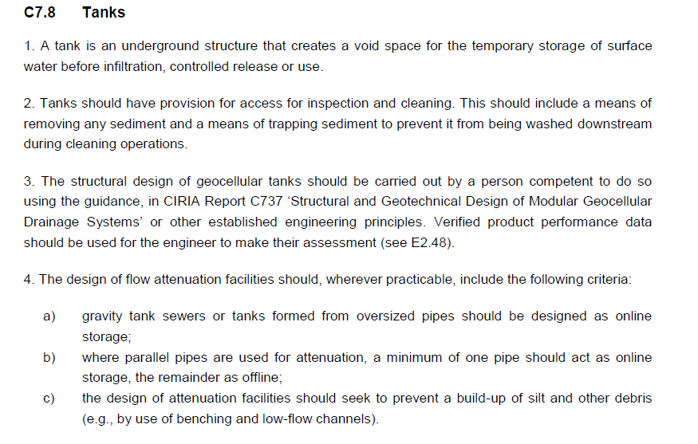
d) Where half pipe or arch structures are proposed, the design must (in addition to the above) demonstrate how the system can be cleaned/jetted and done so without damage or erosion of base materials or membrane. With further design evidence outlining how in areas of a highwater table, groundwater is kept out of the system and when positioned under highways that the loading criteria is acceptable to both undertaker and adopting Highway Authority (if applicable).

This decision reflects the consensus of all members of the Panel following consideration of the proposal at the meeting on 17th December 2021. This recommendation was made on the basis that it is consistent with the Code principles, particularly in relation to competition and innovation, including not unduly preventing opportunities for innovation that improves services. The Panel was satisfied that the principle of the Proposal enables the DCG to better meet the principles of the Code and that the Panel’s recommended wording also supports this. If Ofwat is minded to accept this recommendation, we suggest that the change should take effect from 1st April 2022. This is in line with other changes recently recommended by the Adoption Panels and so avoids creating confusion with frequent changes to the Code documentation.

I confirm that a copy of this letter has been sent to ADS Pipes and has also been published on the Panel’s website.
If you require any further information or if the Panel can assist any further regarding the proposal, please let me know.
Yours sincerely,

Victor Olowe
Chair
Independent Sewerage Adoption Panel

